**Barron’s Let’s Review Regents – Algebra I**

# Chapter 6: Graphing Solution Sets for Quadratic Equations

## 6.1 Graphing Solution Sets to Quadratic Equations

**Graphing Solution Sets to Quadratic Equations by Making a Table**

|  |  |
| --- | --- |
| **x** | **y** |
| -2 | 4 |
| -1 | 1 |
| 0 | 0 |
| 1 | 1 |
| 2 | 2 |

Graphing Solution Sets to Square Root Equations by Making a Table

|  |  |
| --- | --- |
| **x** | **y** |
| 0 | 2 |
| 1 | 3 |
| 4 | 4 |
| 9 | 5 |

**The Axis of Symmetry and the Vertex of a Parabola**

Every parabola has an *axis of symmetry*, usually a vertical line that divides the parabola into two equal pieces. The axis of symmetry passes through the *vertex* of the parabola, which is the point where it changes from decreasing to increasing, or from increasing to decreasing.

**Using the Axis of Symmetry to Pick x-Values for a Table**

Rather than always use the five x-values -2, -1, 0, 1, and 2, it is better to use as the middle number the   
x-intercept of the axis of symmetry. To determine the x-intercept of the axis of symmetry, of a quadratic equation in the form , use the formula:

Determining the Coordinates of the Vertex of the Parabola

Because the vertex is on the axis of symmetry, the   
x-coordinate of the parabola that is the graph of the solution set of is To determine the y-coordinate, substitute for the x value you get for into the equation .

Equation: , the x-coordinate of the vertex is .

**Graphing Parabolas with the Vertex and Intercepts Method**

When a parabola has two x-intercepts, four points are very useful: the vertex, the y-intercept, and the two x-intercepts.

The y-intercept can be solved by substituting 0 for x: (0, 8).

The x-intercepts each have a y-coordinate of 0. To calculate them, substitute 0 for y and solve.

This is a quadratic equation covered in Chapter 3. This one can be solved by the factoring method.

So the two x-intercepts are (-4,0) and (-2,0).

**Graphing Solution Sets to Quadratic Equations on the Graphing Calculator**

Intervals When a Graph is increasing or Decreasing

A graph is increasing when as the x-coordinates increase, they y-coordinates increase too. Informally, the graph goes up as it moves right.

The graph of the line y = x is an example of a graph that is increasing everywhere.

Graphs of the solution sets of linear equations are always increasing or always decreasing, depending on whether the slope of the line is positive or negative.

Graphs that form parabolas will switch, at the vertex, from increasing to decreasing or from decreasing to increasing.

### Check Your Understanding of Section 6.1

1. Multiple-Choice
2. Which is a point on the graph of the solution set of   
   **(4) (3, 22)**
3. The parabola defined by the equation   
    has a y-intercept at  
   (y-axis-intercept)  
   **(2) (0, 12)**
4. Which is an x-intercept of the parabola defined by the equation ?  
   (x-axis-intercept => y = 0)  
   **(4) (5, 0)**
5. What are the coordinates of the vertex of the parabola defined by the equation   
   ? (a = 1, b = -4, c = -1)  
   **(4) (2, -5)**
6. What is the equation of the axis of symmetry of the parabola defined by the equation  
   ? (a = 1, b =-6, c = -2)  
   **(3) x = 3**
7. is the x-coordinate of the vertext for the parabola defined by which equation?  
   **(1)**  (a = 1, b = 8, c = 3)
8. What could be the equation that determines this parabola?  
   Vertex: (3, -1)  
   x-intercept: (2, 0), (4, 0)  
   y-intercept: (0, 8)  
   Plug in (2, 0) for each equation to see if it works.  
   **(2)**
9. The axis of symmetry of the parabola defined by the equation is  
   a = 3, b = 42, c = 8  
   **(1)**
10. Which is the graph of ?  
    a = -1, b = 2, c = 3  
    Vertex:   
    Vertex:   
    Vertex: (1, 4)  
    y-intercept:   
    y-intercept: (0, 3)  
    **(2)**
11. Based on this graph, what are the two solutions to the equation ?  
    **(3) x = 3 and x = -1**
12. Show how you arrived at your answers.
13. The graph of the parabola defined by the equation has an axis of symmetry at x = -3. Find possible values for b and c.  
    Multiply both sides by -2.

Completing the square:  
**b = 6, c = 9**

1. The graph of the parabola defined by the equation has x-intercepts at (1, 0) and (-4, 0). What are possible values for *b* and *c*?  
   **b = 3, c = -4**  
   Based on the x-intercepts, factors should be (x – 1) and (x + 4).  
   **(x – 1) (x + 4) = x2 + 4x - x - 4 = x2 + 3x – 4**
2. A portion of a parabola is graphed below. It will pass through the three points (1, 5), (6, 0), and vertex (4, -4). What are two other points on this parabola?  
     
   Each side of the parabola with respect to the vertex mirrors the other side. The mirror to   
   (6, 0) is **(2, 0).** The mirror to (1, 5) is **(7, 5).**
3. What are the coordinates of the vertex and the x-intercept(s) of the parabola defined by the equation   
     
   a = 1, b = -6, c = 9  
   vertex: (3, 0)  
   x-intercept: (3, 0)
4. Below is the graph of . What is the equation of the axis of symmetry of the graph of   
     
   a = 1, b = -6, c = 3  
   vertex: vertex: (3, -6)  
   equation of the axis of symmetry: x = 3

## 6.2 Using the Graphing Calculator to Solve Quadratic Equations

If a quadratic equation does not require a solution that eases algebra, either because it is a multiple-choice question that does not require showing work or because it is a free-response question that does not say “only an algebraic solution will be accepted,” it is possible for the graphing calculator to estimate the answer t oany quadratic equation very quickly.

**Using the Zeros Feature to Solve Quadratic Equations**

**Example 1**

Find the two solutions to the equation  
 on the graphing calculator.

**Example 2**

Use the calculator to find the two exact solutions to the quadratic equation

**Solving Quadratic Equations in Different Forms with the Graphing Calculator**

Example 3

What are the two solutions to the equation

### Check Your Understanding of Section 6.2

1. Multiple-Choice
2. What are the solutions to ?  
   **(2) x = 1, x = -4**
3. What are the solutions to ?  
   **(3) x = -2, x = 5**
4. Solve for all values of x, rounded to the nearest hundredth: .  
   **(3) 3.73, 0.27**
5. Solve for all values of x, rounded to the nearest hundredth: .  
   **(2) -3.59, -6.41**
6. Solve for all values of x:   
   **(2)**
7. Which graph could be used to find the solutions to the equation ?  
   **(1)**
8. The x-intercepts of the parabola defined by which equation are the solutions to the equation ?  
   **(3)**
9. The x-coordinates of the intersection of the line and the parabola are the solutions to which equation?  
   **(3)**
10. Which of these equations does not have the same solutions as the others?  
    **(2)**
11. This is a portion of the graph of the solution set of . What are the approximate solutions to ?  
    **(4) 5.5 and 8.5**
12. Show how you arrived at your answers.
13. Below is the graph of the equation   
    . Use it to estimate the solutions to the equation .  
    A graph of a function

    AI-generated content may be incorrect.  
    **x = 3, x = 6.5**
14. Use the graphing calculator to find the two solutions to .  
    A graph of a function

    AI-generated content may be incorrect.  
    **x = -0.6, x = 1.6**A math equations with black text

    AI-generated content may be incorrect.
15. The x-coordinates of the two intersection points of the line and the parabola are the solutions to what quadratic equation?  
      
    x-intercepts: x = 1, x = 4 (1,0), (4,0)  
    vertex: (2.5, -2)  
    y = (x-1)(x-4) = 5
16. Use the graphing calculator to find the positive solution to the equation   
    A screenshot of a math application

    AI-generated content may be incorrect.  
    **T = 7**
17. To solve the equation , Mary graphs and . Sofia solves it by graphing . Christopher solves it by graphing and . Who is solving it correctly?  
      
    Mary:  
    A graph of a function

    AI-generated content may be incorrect.  
      
    Sofia:  
    A graph of a function

    AI-generated content may be incorrect.  
      
    Christopher:   
      
    A graph of a function

    AI-generated content may be incorrect.  
      
    Mary and Sofia’s method seem to work best and the solution is very clear. Christopher’s solution might work, but the diagonal line makes it difficult to see the solution.  
      
    Book says: All three are correct since the equations are all equivalent. One can be turned into the other by using the addition property of equality.

## 6.3 Solving Linear-Quadratic Systems of Equations

A system of equations in which one of the equations is linear (having no exponents greater than or equal to two) and the other is quadratic (having at least one exponent equal to two and all others equal to one) is called a *linear-quadratic* system of equations. Two methods for solving such systems are the graphing method and the substitution method.

If the system of equations is

all the ordered pairs that satisfy both equations at the same time are in the solution set for this system of equations.

There are often two ordered pairs in a solution set for a system like this.

**Solving a Linear-Quadratic System of Equations with a Table**

|  |  |  |
| --- | --- | --- |
| **x** |  |  |
| -3 | 18 | -2 |
| -2 | 8 | 0 |
| -1 | 2 | 2 |
| 0 | 0 | 4 |
| 1 | 2 | 6 |
| 2 | 8 | 8 |
| 3 | 18 | 10 |

From this table, it can be seen that x = -1, both and equal 2. And for x = 2, both and equal 8. So, two solutions are (-1, 2) and (2, 8).

**Solving a Linear-Quadratic System of Equations with Algebra**

If the equations are in the form and , set the expressions equal to each other and solve for x with algebra.

Divide by 2  
Points: (2, 8), (-1, 2)  
**Solving a Linear-Quadratic Systems of Equations with a Graph**

Solution Set: (-1, 2), (2, 8)

**Solving a Linear-Quadratic System of Equations with the Graphing Calculator**

**Same as previous.**

### Check Your Understanding of Section 6.3

1. Multiple-Choice
2. Use the graphing calculator to find which ordered pair is a solution to the system.  
   **(2) (2, 4)**
3. Use the graphing calculator to find which ordered pair is a solution to the system.  
   **(2) (1, 2)**
4. Use the graphing calculator to find which ordered pair is a solution to the system.  
   **(3) (5, 2)**
5. Solve this system of equations using algebra.  
   **(2) (-1, 1) and (3, 9)**
6. Use the graphing calculator to find both solutions to the system.  
   **(4) (-1, 2) and (2, 8)**
7. Use the graphing calculator to find both solutions to the system.  
   **(4) (0, 0) and (1, 3)**
8. Solve this system of equations algebraically.  
   Solution Set: (-2, 10), (3, 5)  
   **(2) (3, 5) and (-2, 10)**
9. Solve this system using any method you want.  
   **(1) (2, 6) and (-3, 1)**
10. Which system of equations could this graph be used to solve?  
    Point 2: (2, 4)  
    Point 1: (0, 1)  
    **(3) ,**
11. Graphically, find all solutions to the system of equations.  
    **(1) (2,4)**A screenshot of a math problem

    AI-generated content may be incorrect.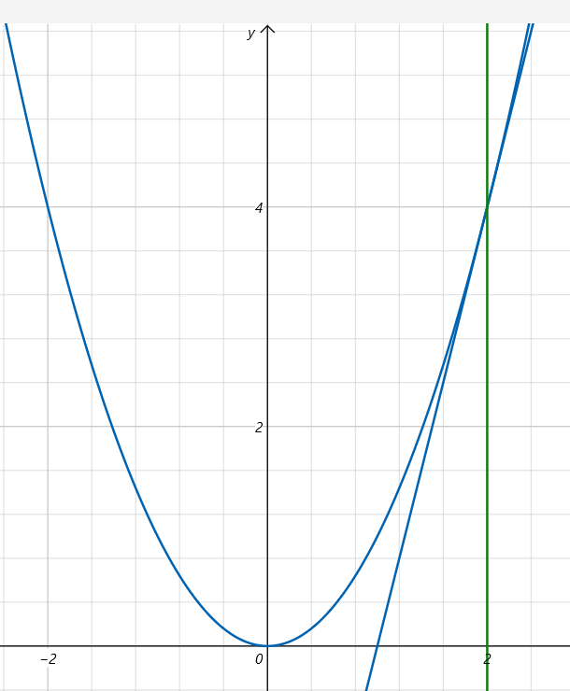
12. Show how you arrived at your answers.
13. Find the two solutions to the system of equations using the graphing calculator.  
    **Solutions: (-2, 2), (4, 8)**A graph of a function

    AI-generated content may be incorrect.
14. Solve this system using an algebraic method. Any other method will not be accepted.  
    **Solution Set: (0, 5), (3, 8)**
15. Use a graphing calculator to find the two solutions to the system of equations.  
    **Solution Set: (2.7, 5.1), (6, 4)**A graph with a line and a point

    AI-generated content may be incorrect.
16. Based on the graph below, Kaydence says there is just one solution to the system of equations. Jimena says there are two solutions. Who is correct, and why?  
    **Solution Set: (-1, 3), (3, 27)  
    Jimena is correct. There are two solutions. One solution is not visible on the chart because it occurs at (3, 27), and the y-axis only goes up to 7.39.**
17. Find a value of b so that the system of equations has exactly (a) 2 solutions and (b) 0 solutions.  
    (a) b = 3, (-1, 1), (3, 9)  
    A graph of a function

    AI-generated content may be incorrect.  
    (b) b = -5,   
    a = 1, b = -2, c = -5  
    Since the discriminant is negative, there are no real solutions (just zero solutions).  
      
    A graph of a function

    AI-generated content may be incorrect.